Three years PhD position in France (Paris, LSCE) seconded in Sweden
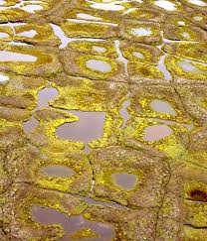 | 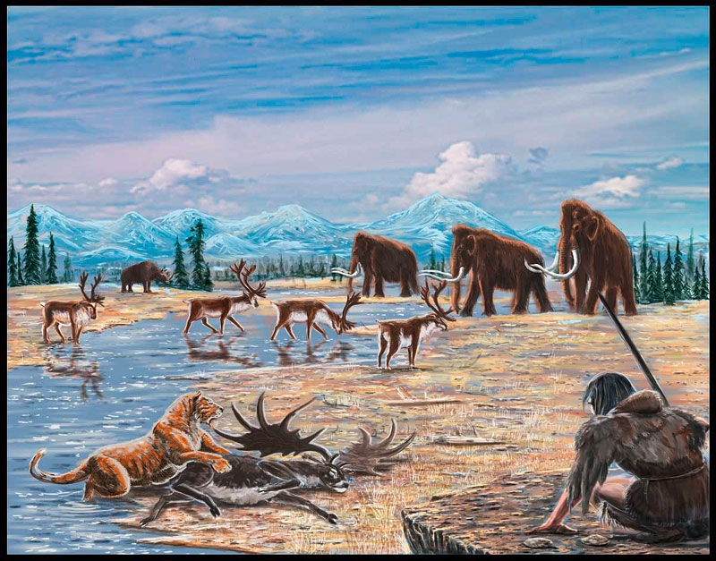 | 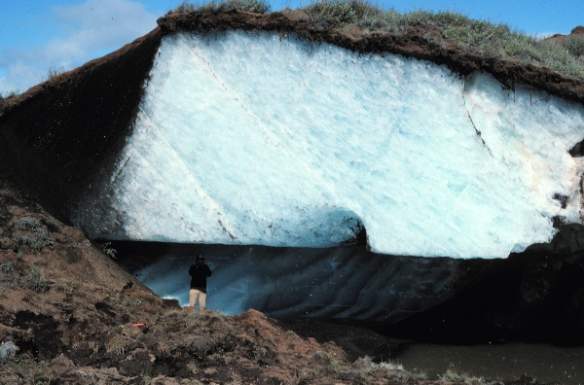 | 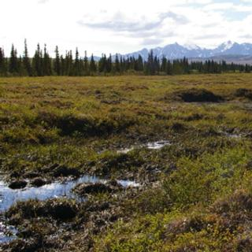 | 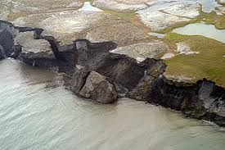
Modeling permafrost carbon stocks during the last Ice Age and effects on atmospheric CO₂

This position is funded through the ‘Common Research Training Program in the Climate, Environment and Energy Agreement between VR, Formas and LSCE’ (Sweden and France). The PhD student will contribute to the understanding of Glacial Epoch Permafrost Carbon Pools and Fluxes.

Subject
Understanding the rise of nearly 100 ppm in atmospheric CO₂ associated with glacial-interglacial transitions remains an enigma. Better knowledge of carbon reservoirs during full glacial periods is needed. Isotopic 13C budget tend to indicate that the terrestrial biosphere contained 360 Pg C less carbon in the Last Glacial Maximum compared to the pre-industrial time, yet with a large area of unproductive but carbon-rich biomes. In addition to tundra and cold steppes containing large amounts of soil carbon, an inert carbon pool of ~ 2000 Pg C has been inferred, which exceeds carbon accumulated in permafrost today by more than 700 Pg C. This large terrestrial inert pool partly disappeared during the climate warming to the Holocene, and may have contributed to the de-glacial rise in atmospheric CO₂.
Despite the likelihood of large permafrost carbon stores during glacial periods, their inclusion, even under a simplified form, in carbon cycle models is still missing. The PhD candidate will use and further develop the process-based ecosystem model ORCHIDEE forced by climate simulations of the Last Glacial Maximum in order to simulate the extent and distribution of permafrost carbon stores, and evaluate the model results using new paleo-environmental reconstructions, in the following steps:
1. Conduct process-based modeling of permafrost soil carbon pools, fluxes and related surface processes using the ORCHIDEE ecosystem models and climate fields from the PMIP ensemble of models
2. Compare and evaluate the model output against independent observation-derived estimates of permafrost carbon pools, based on paleo-environmental reconstructions of Last Glacial Maximum periglacial landscapes, in collaboration with Stockholm University.
3. Estimate CO2 and CH4 fluxes for different landscape types under glacial epoch conditions, based on available experiments and process understanding, in collaboration with Lund University.
4. Synthesize results in publications, where the reconstructed past changes in permafrost carbon will be used for reducing uncertainty on future permafrost thawing in response to climate change

Applications
The PhD student will be hosted by LSCE near Paris during three years, with visits to Stockholm University and Lund University (Sweden). The work will be carried out in an active project team composed of Philippe Ciais, Peter Kuhry and Torben Christensen (co-supervisors), Masa Kageyama, Gerhard Krinner and Philippe Peylin. The candidate will also work closely with another PhD student on vegetation dynamics in high latitudes, within the same Swedish-French program. Applications will be reviewed by a scientific committee from CEA (one of the tutelary institutions of LSCE).
The gross salary is of 2043 euros/month, upgraded to 2104 euros/month during the last year. This includes full healthcare and pension benefits, and is equivalent to a net salary of ~1750 euros/months.
Candidates are sought with a background in physics, earth sciences, good skills in informatics and modeling, as well as enthusiasm for global enigmas. Please send applications with a CV and a letter of motivation to Philippe Ciais (philippe.ciais@cea.fr) and Peter Kuhry (peter.kuhry@natgeo.su.se) before February 15th, 2013.

